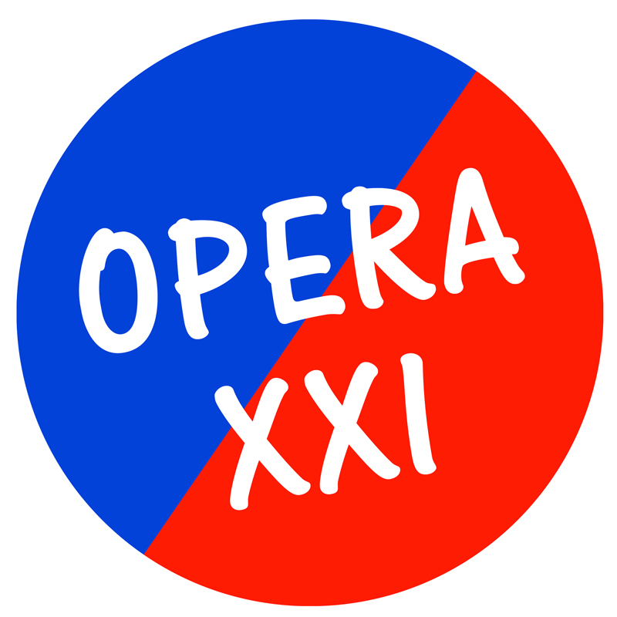
INVITATION CONFERENCE
20th May – 22nd May
Antwerp - Ghent

Vlaamse Opera, the International Arts Campus deSingel, Music Theatre Transparant and Production House LOD have the honour to invite you to the Conference and Symposium on the occasion of the biannual Festival of Contemporary Music Theatre OPERA XXI.

This years theme is:
“A LITTLE BIT OF OPERA?”
On Chamber Opera and Small Scale Music Theatre.
From Friday 20th May till Sunday 22nd May in Ghent and Antwerp.

This conference is intended for organizers, artists (composers, directors), dramaturges, researchers, theatre and musical-theatre students and members of the public who are interested in contemporary musical theatre.
OPERA XXI is a festival for first performances of contemporary work. It warmly welcomes experiment and takes a broad view. This year we shall be turning the spotlight on chamber opera.
No less than five productions will be presented, three of them performed for the first time, ranging from the symbolist world of Maurice Maeterlinck to the negotiation tables of the Middle East. From Greek tragedy to martyrs.

During the conference you will be able to attend three new music theatre productions, two of which are world premieres.

The conference will be held in English.
The detailed program will be announced shortly at www.operaxxi.be.

To register please contact the Vlaamse Opera box office at 0032 (0)70/22.02.02 or email us info@vlaamseopera.be with the mention of OPERA XXI Conference.
You can find further information about the festival and the conference in the attachment or at: www.operaxxi.be.

Prices:
General price: 80 euro (3 performances included)
Symposium price: 25 euro (Only Saturday and no performances included)
Student price: 15 euro (no performances included)

Because of technical reasons you might receive this message more than once. Please do excuses us for this inconvenient.)

